**Final Project Report**

**Student: Hsuan-Pei Lee NUID:002838616**

1. **Inspiration**

Play style: Darkest Dungeon

Story: Agatha All Along (Marver’s TV show)

1. **Structure of the final project**

(Not every object in each scene would be mentioned)

Two Scenes: **StartMenu** + **SampleScene**

StartMenu ----- Canvas ----- TitleImg(Background Image)

|-- FadePanel

|-- GameTitle(Title Text)   
 |-- PlayButton(Start Button)

|-- ExitButton

|-- BackgroundMusic

|-- MainMenuManager

|-- SceneTransitionManager

SampleScene ----- Background Canvas

|-- HeadsUpCanavas

| |-- Main Panel

| |-- Action Menu(contains the panel with images of actions)

| |-- HeroInfo (contains Hero’s name, image, health bar, etc.)

| |-- EnemyInfo (contains Enemy’s name, image, health bar, etc.)

| |-- YourTurnText

|-- GameControllerObject

|-- WizardHero

| |--WMeleePrefab

| |--WRangePrefab

|-- Monster

|--EMeleePrefab

|--ERangePrefab

1. **Scripts**

(The brief introduction toward scripts is provided in the demo video)

Assets/Scripts/MainMenuManager.cs

Assets/Scripts/ SceneTransitionManager.cs

Assets/Scripts/ MakeButton.cs

Assets/Scripts/ GameController.cs

Assets/Scripts/ FighterStats.cs

Assets/Scripts/ FighterAction.cs

Assets/Scripts/ AttackScript.cs

1. **Animation**

Hero:

1. Idle  
   A screenshot of a computer

   AI-generated content may be incorrect.

1. Melee

1. Range

1. Injury

Enemy:

1. Idle

1. Melee

1. Range

1. Injury

1. **What I have done?**

This project was based on a YouTube tutorial (see the **Credits** section), but I have revised the files from the tutorial and implemented two additional scripts for the menu and the StartMenu scene to create a more formal game experience. Additionally, I have added two soundtracks (see the **Credits** section) as background music.

Some examples of the files I programmed, revised, or created:

MainMenuManager.cs:

SceneTransitionManager.cs:

1. **Screenshots of The Game**

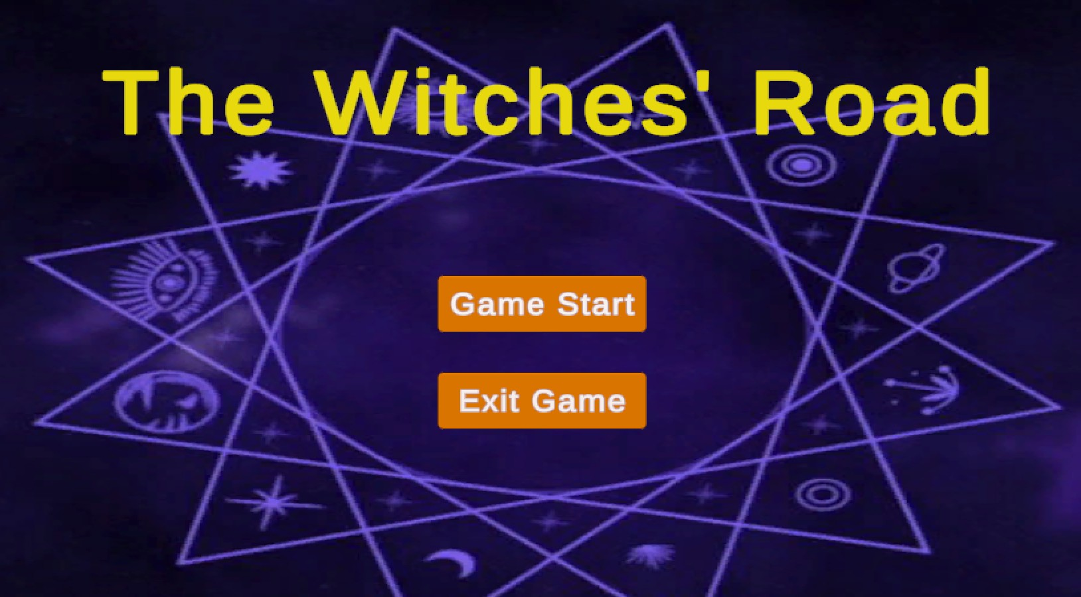

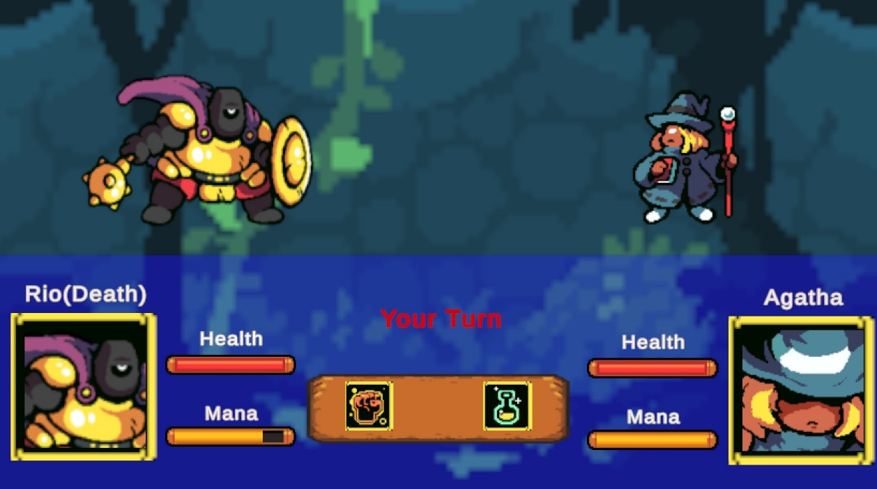

1. **Portfolio**

Link: [The Witches' Road](https://v0-final-project-portfolio-hp-lee.vercel.app/)

(created by V0)

1. **How to Play?**

You can find the executable file ***Final Project_Hsuan-Pei Lee*** under the directory ***build_final***

1. **Credits**
2. Youtube tutorial

[kurtkaiser/RPG-Battle-Game-Video: RPG battle system, this game was built for a YouTube tutorial.](https://github.com/kurtkaiser/RPG-Battle-Game-Video/tree/master)

1. Soundtrack 1: **The Ballad of the Witches' Road - Agatha All Along | EPIC VERSION**

[The Ballad of the Witches' Road - Agatha All Along | EPIC VERSION](https://www.youtube.com/watch?v=nmeeLmB95E8)

1. Soundtrack 2: **14 Baldur's Gate 3 Original Soundtrack - Twisted Force (Battle Music 3)**

[14 Baldur's Gate 3 Original Soundtrack - Twisted Force (Battle Music 3)](https://www.youtube.com/watch?v=MW1bBywTExU)

1. **Licensing and Professionalism**

* License: [MIT License] (See LICENSE.txt)

1. **Video**

The demo video (Demo video.mp4) can be found in the folder.